Toothbrush Orders and Deliveries

Introduction
Toothbrush orders and deliveries is the online tool which analysis and generate the data based on different toothbrush types. It also helps understand customer behavior and track their buying habits.
Project Requirements
This project requires setting up python script which is schedule to run ideally once a day. Python script will generate CSV file which is then stores for data modeling and data cleansing for stagging area. Upon staging it should invoke any methodology to automatically store the data using data pipeline data to database or data warehouse. Finally, frontend is created to display the insight.
Technology used
Toothbrush orders and deliveries uses a cloud platform, visualization tools and frontend end to display insight.
Cloud Platform:
Cloud platform such as “Amazon Web Services” to take an advantage of different services. The AWS services used in this application are followed.
ec2:
To run python script automatically an ec2 instance is created and python script is setup by using Cron job. Cron jobs is a scheduler which needs to setup manually and then it will automatically invoke any process.

Instance creation:

Instance can be launched by clicking on “Launch Instance”

After the instance is being launch, we need to provide a name for our ec2 instance.
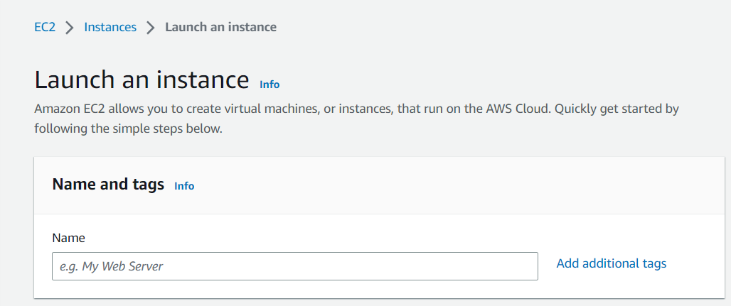

Once we named the ec2 instance we need to select the operating system for our instance.

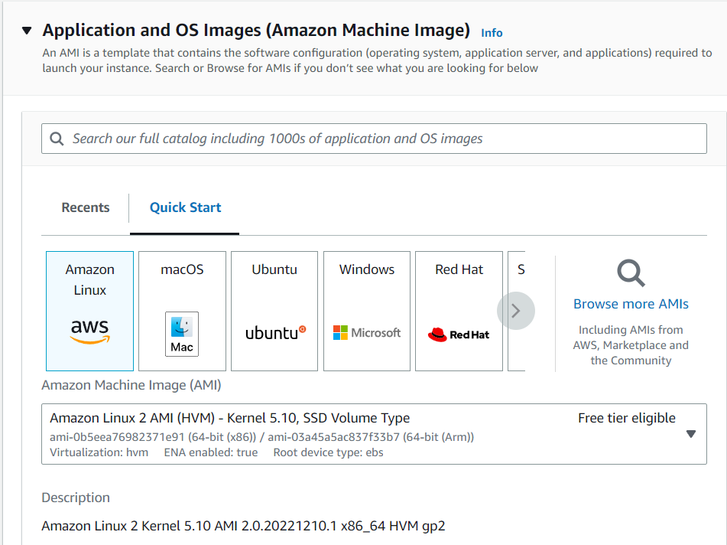

After selecting the desire operating system, we need to select our instance type.
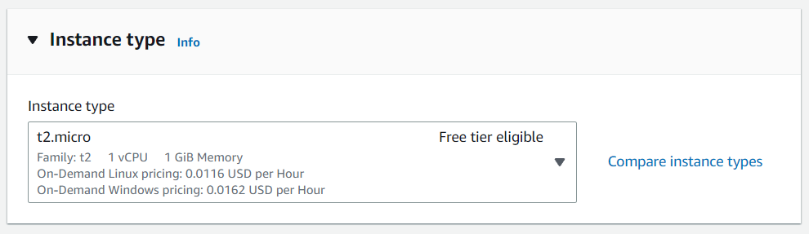

For the next step, we need to create the key pair which help us to connect with our ec2 instance.

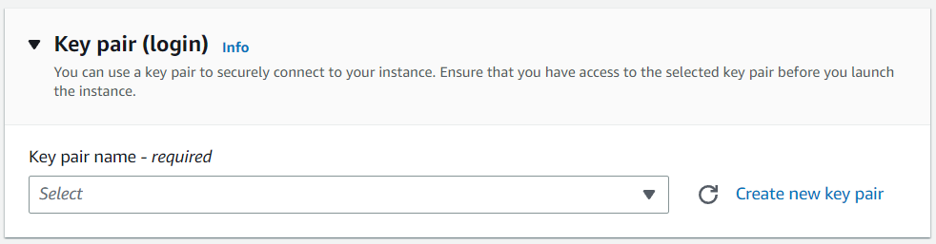

We also need to define “Security Group”. These security group consist of inbound and outbound rules. Inbound rules define which comes in and outbound define what goes out. These rules are controlling inbound and outbound traffic. By setting up these rules we are allowing different application or different services to allow access.

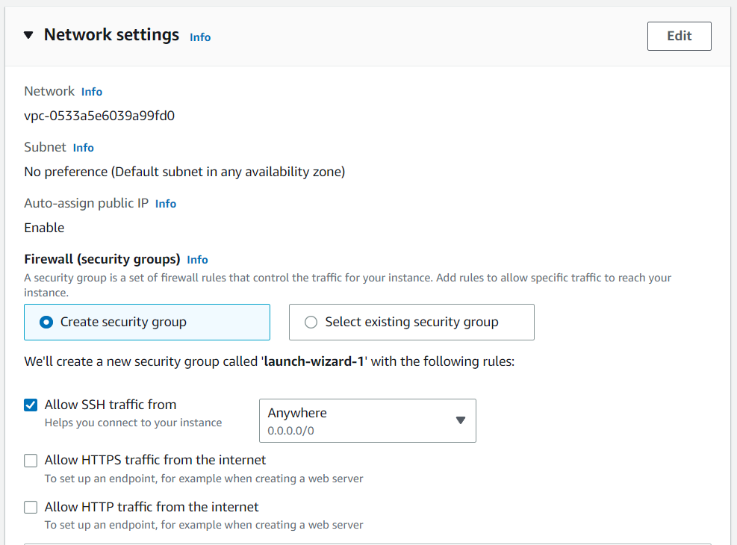

Finally, we can select out storage type and we can launch the instance. To connect with instance, we need to select the instance we would like to work with.

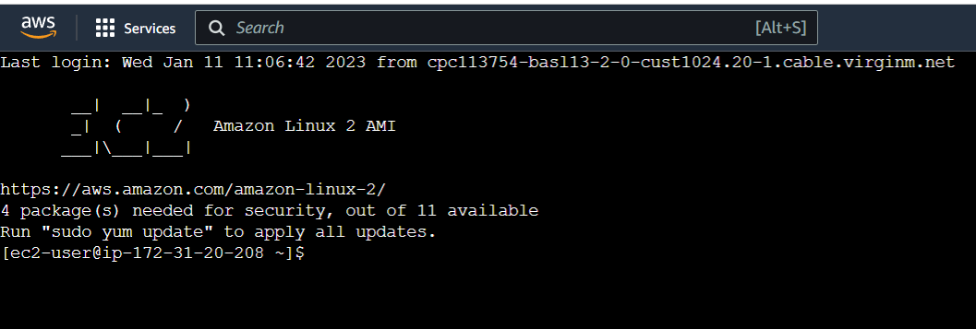

S3 :
It is a simple storage service by amazon which provides cloud storage. Once the python script runs on ec2 instance the generated CSV file are then moved to S3 for staging area. S3 consists of different buckets. To create a bucket, steps are follows.
We need to select create bucket. We should named our bucket uniquely follows by bucket region.
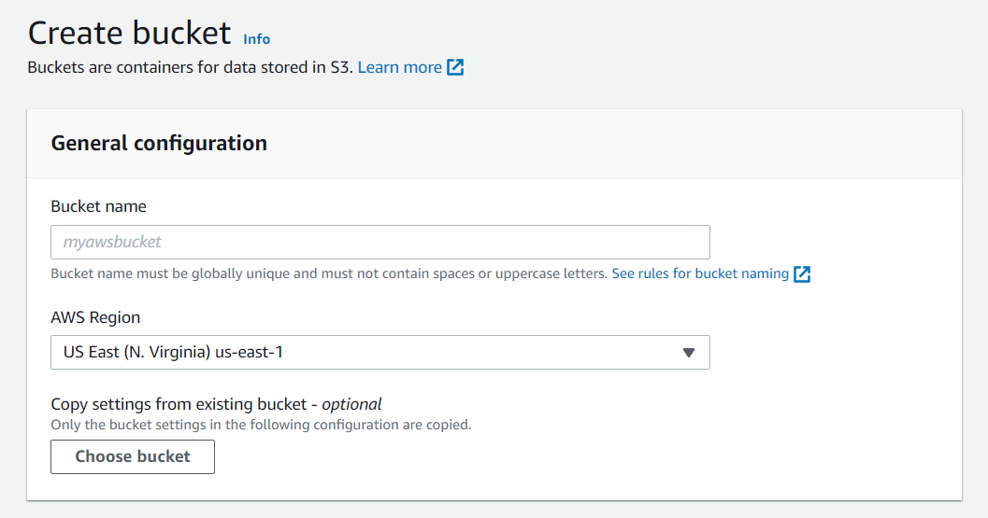
We can grant or block public access for the bucket.
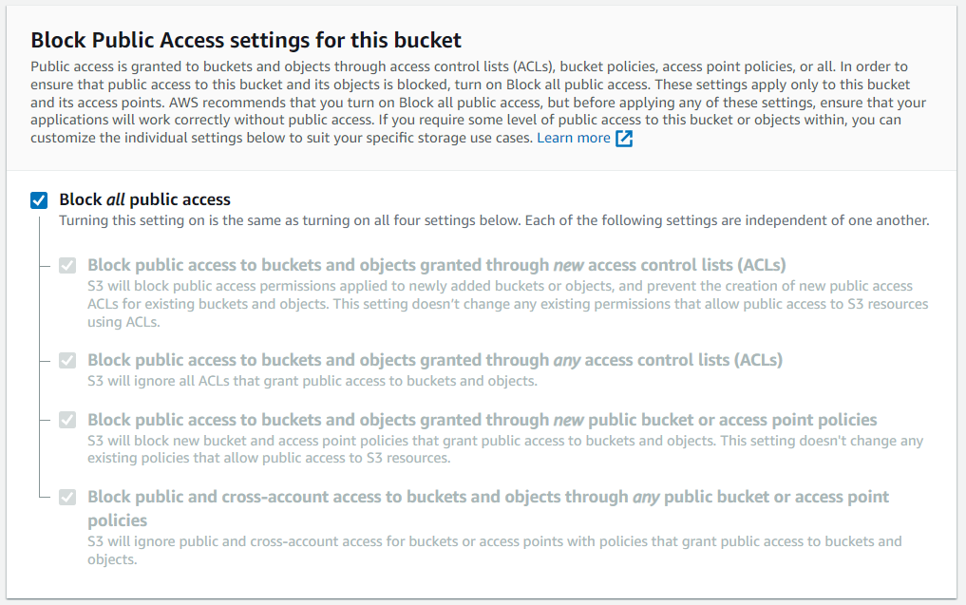
We can also enables bucket versioning and finally we can create a bucket.
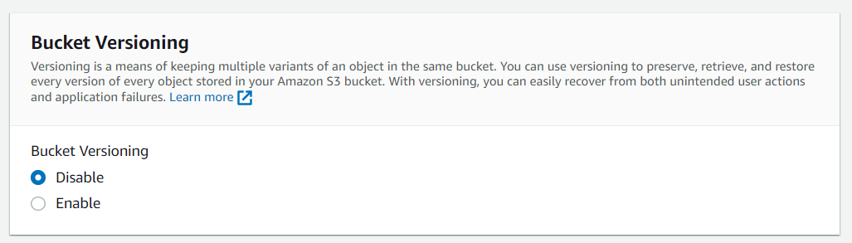

S3 Trigger:
When ever a file is uploaded on S3 it will trigger a lambda function automatically. To create a trigger on lambda function steps are follows.
Select the bucket and select bucket properties.
We can setup a trigger on s3 using event notification. For our project purpose we have used put and post method it will generate an event whenever a file is uploaded on lambda.
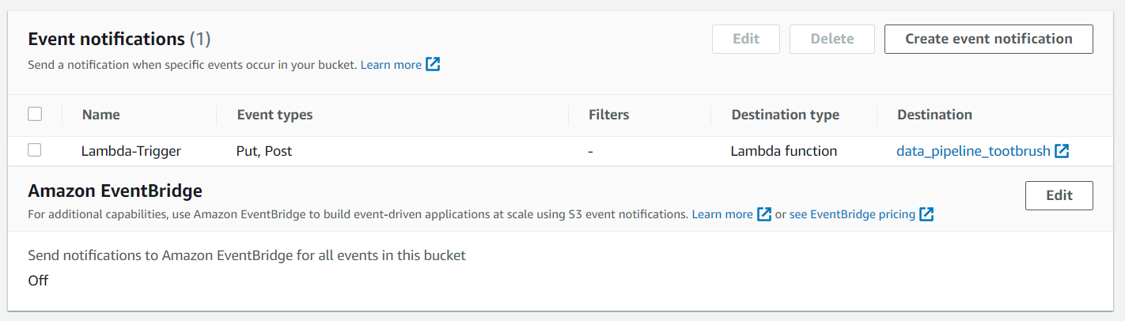
Lambda function
Lambda functions are small functions which works as a microservices. Lambda function will be automatically invokes when a file is added on s3. For this project we added a trigger on lambda. To add a trigger on lambda we select add trigger and added our trigger from s3.
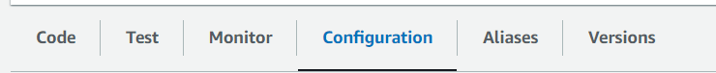
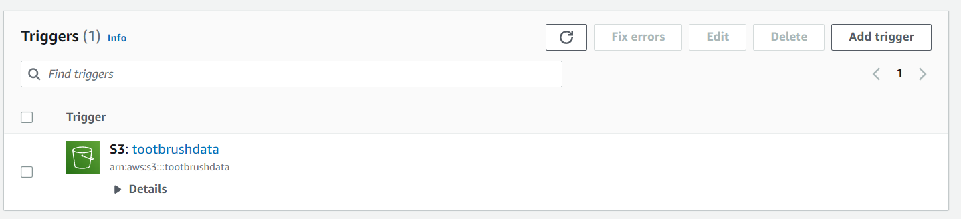

RedShift :
Redshift is the data warehouse which is used to analyze structured and semi-structures data across data warehouses and data lakes. After the lambda function invokes the data generated by python script is stored in RedShift cluster. The data pipeline is created for this purpose and different VPC are defined.
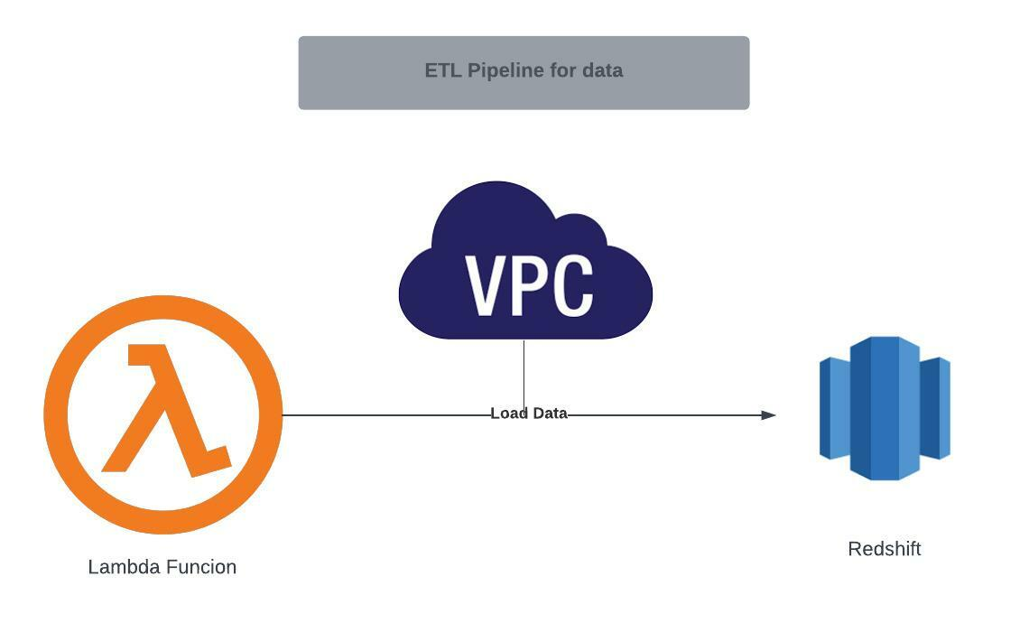
Visualization tools:
This webapp generates insight from data to display some useful information. Insights are generated on the basic of redshift data. These insights are dynamic and refreshes every time when new data is inserted into the cluster.
Data visualization / analytics tools used are AWS QuickSight and ThoughSpot.
QuickSight and ThoughSpot is connected with redshift to manipulate data and generated insights.
Embed a QuickSight dashboard into frontend.
To embed Aws QuickSight new IAM roles was defined which is QSAnonomousdashboard and then we need to install AWS CLI. To generate embedded dashboard url we need to type command
aws quicksight get-dashboared-embed-url – AWS REGION --namespace default --dashboared-id DASHBOARD ID --identity-type ANONYMOUS --aws-account-id AWS ACCOUNT ID
Embed a ThoughSpot dashboard into frontend.
To embed a ThoughSpot live dashboard into frontend. ThoughtSpot SDK is used with JavaScript by providing dashboard id and ThoughSpot id.

Frond end:
This webapp uses HTML, CSS, and JavaScript to create a frond end to embed insight in the webapp.

System Requirements:
This project is based on web which requires any web browser such as google chrome, Firefox, safari etc.

Sequence diagram:
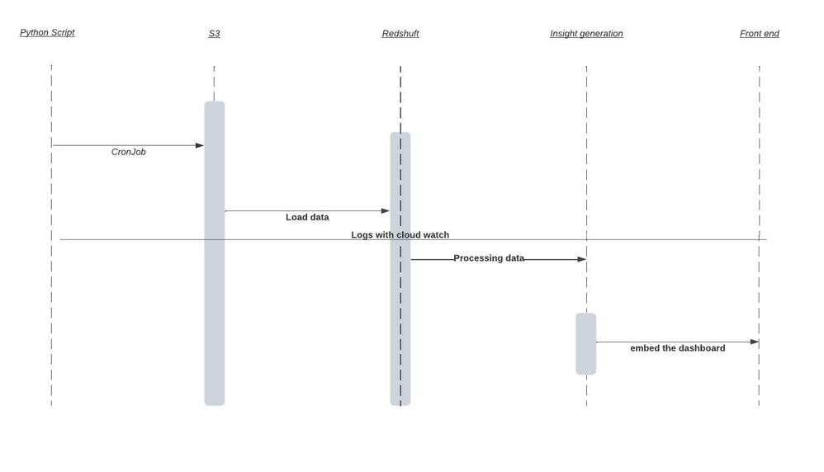

Project Summary:
This project has used different AWS services by authenticated different IAM roles along with different data visualization tools. Data visualization tools generated the insights and based on insight live dashboard was generated. Frond is built by using HTML, CSS, JavaScript, and bootstrap. The data is live, and every time new data is added into data warehouse it updated automatically.

Project Overview:
This diagram summarizes the whole project and how different services are used.

